Skill Using FL Reading Getting Things Done

**Form**

* **Copy.**

1. 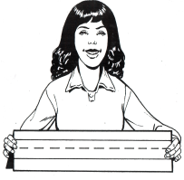 **First Name** ____________________________________________
2.  **Last Name** ____________________________________________

**3. 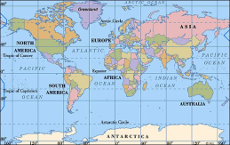 Country** _____________________________________________

|  |  |
| --- | --- |
| Image result for Somalia Flag **Somalia** | Image result for Congo Flag **Congo** |
| Image result for Rwanda Flag **Rwanda** | Image result for Sudan Flag **Sudan** |
| Image result for Myanmar Flag **Myanmar** | Image result for Ivory coast Flag **Ivory Coast** |
| Image result for Eritrea Flag **Eritrea** | Image result for Syria  Flag **Syria** |