Skill Using FL Writing Sharing Information Teacher: Jen L.
Date _____________________________________________________________________

How Many Children Do You Have?
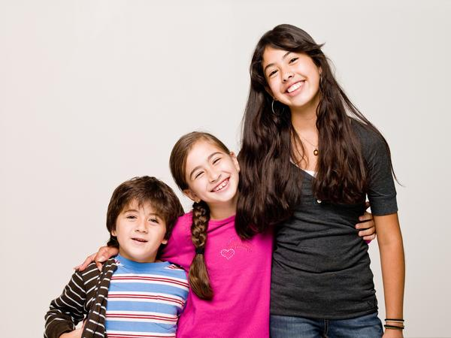

0 1 2 3 4 5 6

7 8 9 10 11 12 13
Copy
0 ______ ______ ______ ______ ______ ______
______ ______ ______ ______ ______ ______ 13

I have ______ children.

