Skill Using FL Reading Comprehending Information Teacher: Jen L.

**Name** ________________________________________________________________

**Date** _________________________________________________________________

Memo

**Holiday Potluck**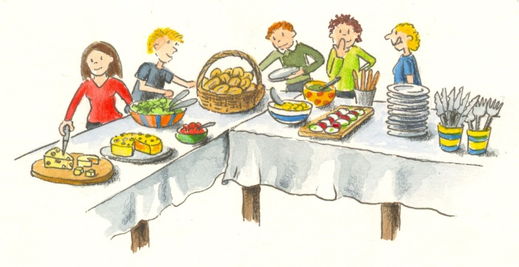

**December 22, 2017**

**400 Edmonton St.**

**2:00 pm**

 **Underline**

**month**

**time**

**date**

**Name** _________________________________________________________________

**Date** _________________________________________________________________

Memo

**Back to School**

**January 8, 2018**

**275 Portage Ave.**

**Room 1012**

**9:15 am**

**Circle**

**address**

**time**

**year**



**FL - Reading**

**Theme: Calendar**

**Task: Read a memo to find key words.**

**Competency: Comprehending Information**

**Teacher’s Assessment**

|  |  |  |  |
| --- | --- | --- | --- |
|  | **Needs More Practice** | **Almost** | **Achieved** |
| 1. Identified address in memo. |  |  |  |
| 2. Identified time in memo. |  |  |  |
| 3. Identified year in memo. |  |  |  |

Success

|  |
| --- |
| √ |

**________________________________________**

**Student Self-Reflection**

 