Skill Using FL Writing Reproducing Information Teacher: Jen L.

Name ____________________________________________________________________
Date ______________________________________________________________________

Thank You Card
Dear _____________________________ ,

Thank you for teaching the class.

I liked learning about

________________________________________

From,

____________________________________

 | Not Yet | Almost | Yes
Forms letters clearly.
Uses uppercase letters for names.
Appropriate drawing for Thank You

Name _________________________________________________________________

Date __________________________________________________________________

Thank You Card
Copy name. Deliver card to substitute.

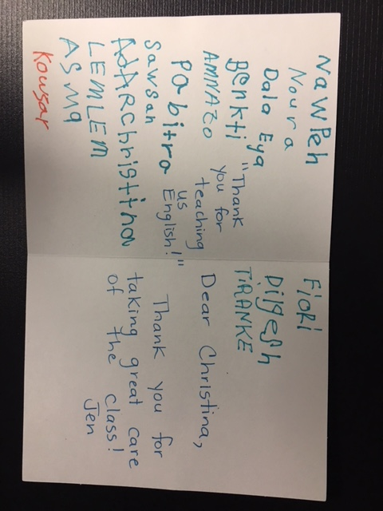

FL - Writing
Theme: Community
Task: Copy name on a greeting card
Competency: Interacting with Others
Teacher’s Assessment No Yes
Part A: Task was completed.
 | Needs More Practice | Almost | Achieved
Part B:
1. Form letters clearly.
2. Copy complete name.
3. Deliver card with classmates.
4. Understand the card expresses thanks.

Success
√

