TASK ASSESSMENT

Name: ________________________ Date: _Nov 22/26, 2018____

CLB Competency & Level ___CLB 3 – Listening – Getting Things Done_

Real World Task: Listening to a TV ad.

 | Can’t do yet  (0) | Can do frequently  (1) | Can do most or all of the time  (2)
Criteria of the task:
- Understands the main idea (Q1)
- Listens and watches for facts (Q2 & 3)
- Listens for important words or pictures (Q4,5)
- Listens and watches for persuasive phrases and pictures (Q6)
- Understands formal or casual style (Q7)

Rating: To do this task successfully, the total must equal 7 or higher.

Total _______ / 10
Rating Scale: 0-4 – not working at this level yet 5 – beginning to work at this level
6 – developing 7 – satisfactory 8 -10 – more than satisfactory

Comments:
Something you did very well: | Something to work on for next time:

TASK ASSESSMENT

Name: ________________________ Date: __Nov 22/26, 2018___

CLB Competency & Level ___CLB 4 – Listening – Getting Things Done_

Real World Task: Listening to a TV ad.

 | Can’t do yet  (0) | Can do frequently  (1) | Can do most or all of the time  (2)
Criteria of the task:
- Understands the purpose and main idea (Q1,8)
- Listens and watches for facts and formal or casual style (Q2,3,7)
- Listens and watches for important words and pictures (Q4,5)
- Listens and watches for persuasive phrases and pictures (Q6)
- Understands implied meanings (Q9,10)

Rating: To do this task successfully, the total must equal 7 or higher.

Total _______ / 10
Rating Scale: 0-4 – not working at this level yet 5 – beginning to work at this level
6 – developing 7 – satisfactory 8 -10 – more than satisfactory

Comments:
Something you did very well: | Something to work on for next time:

Name _____________________________ Date _______________
Assessment Practice CLB 3/4 – Listening to TV Ads 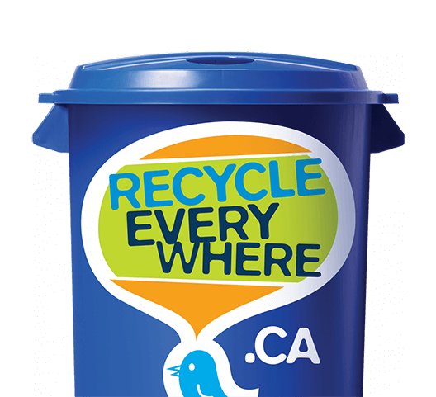
Directions: Answer the questions below.
(CLB 3)
1. What is the main idea of this TV ad?
a. it’s an ad to persuade you to shop at a mall
b. it’s an ad to persuade you to recycle drink bottles at a mall
c. it’s an ad to persuade you to buy food at a mall

2. Where is this ad taking place? __________________________________
3. What is the ‘thing’ that is talking? _________________________________
4. What does the ‘thing’ say after someone puts in an empty beverage can inside it? ___________________________________________________________
______________________________________________________________
5. What is one request that you hear in this ad? _________________________
______________________________________________________________

6. What do you see or hear that makes you feel the talking thing is ‘friendly’?
______________________________________________________________
______________________________________________________________

7. Is this ad more formal or more casual? ______________________________

(CLB 4)

8. What is the purpose of this ad?
a. to sell you something
b. to get you to take action
c. to give you information

9. Why do you think this ad was filmed in the place where it was filmed? _______
______________________________________________________________
______________________________________________________________

10. What is one thing that is important about the phase “Recycle Everywhere”?
______________________________________________________________
______________________________________________________________

Video retrieved on November 20, 2018 from: https://www.youtube.com/watch?v=awU_anibKx8

Name _____________________________ Date _______________

Assessment Worksheet - CLB 3/4

Listening to a TV Ad

Directions: Answer the questions below.
(CLB 3)

1. What is the main idea of this TV ad?
a. it’s an ad to persuade you to drive more carefully
b. it’s an ad to persuade you to support young people going into space
c. it’s an ad to persuade you use your phone while driving

2. Where is one place you see Luke in this ad? __________________________
3. How many Manitobans die on our roads each year? _____________________
4. What does Luke enjoy talking about? _______________________________
5. What is one reason the video shows why people die on our roads? ___________
______________________________________________________________
6. What are the missing words that you hear in this phrase:
“ but, we ________________________________ about it”.

7. Is this ad more formal or more casual? ______________________________

(CLB 4)

8. What is the purpose of this ad?
a. to give you information
b. to sell you something
c. to get you to take action

9. Why does the ad say that ”today is a good day” for Luke? ________________
______________________________________________________________
______________________________________________________________

10. Why is the number “89” over Luke’s head? __________________________
______________________________________________________________

Video retrieved on November 21, 2018 from: https://www.youtube.com/watch?v=IV7fibHW9GE

Name _____________________________ Date _______________
Assessment Makeup CLB 3/4
Listening to a TV Ad
Directions: Answer the questions below.
(CLB 3)
1. What is the main idea of this TV ad?
a. it’s an ad to persuade you to ride a skateboard to Red River College
b. it’s an ad to get you to buy products at Red River College
c. it’s an ad to show you where Red River College graduates can work

2. What are 2 different workplaces where you see graduates from Red River College working in this ad?
a. ____________________________ b. _____________________

3. What is the young man who is working with children doing? ______________

4. What is one place you see in the ad that is in Winnipeg that you recognize?
_____________________________________________________________
5. What is one thing that the announcer says Red River College knows how to do?
______________________________________________________________
6. Fill in the missing words you hear in this phrase:
“ …and say, We _________________________! ”

7. Is this ad more serious and formal or more light and casual? ______________

(CLB 4)

8. What is the purpose of this ad?
a. to get you to take action
b. to sell you something
c. to invite you to look at something

9. Why do you think the ad says at the end, ”What We’re Doing is Working”?
______________________________________________________________
______________________________________________________________

10. Why do you think this ad shows many different graduates doing different things?
______________________________________________________________
______________________________________________________________

Retrieved on November 27, 2018 from: https://billacheson.ca/rrcworkscampaign Voice – Joanne Kelly

Suggestion: Play the ad 3 or 4 times – depending upon sound quality. Then read the text for the students once.
First simple sample:
A - https://www.ispot.tv/ad/wd1V/all-free-clear-detergent-all-you-need#
All you need for sensitive skin
All you expect from the number 1 recommended by dermatologists
All Free Clear is free of dyes and perfumes and has powerful stain lifters to help get your whole wash clean.
It’s All good.

Assessment Practice
C - https://www.youtube.com/watch?v=awU_anibKx8
Hey could someone hold that door for me! I get so lost when I’m hanging out in the mall.
I need some new duds.
Hey what are you lookin’ at?! You want to take me shopping? You act like you‘ve never seen a talking recycling bin.
Hey how you doin’? Oops – sorry. Didn’t mean to scare ya.
Oooo – rides. I’m a flying recycling bin!
That’s what I like. I like the empty bottle. Yup.
Announcer: We’re doing whatever it takes to get empty beverage containers into recycling bins. Are you? Recycle everywhere!

Assessment:
MPI - https://www.youtube.com/watch?v=IV7fibHW9GE
Luke is going into space one day. It’s all he ever talks about. It’s more than a dream. It’s his future, and today - today is a good day. But, today would be the last day of his life. Luke is one of the 100 Manitobans to die on our roads this year, but we can do something about it. His life matters. They all do.
Make up Assessment
RRC: https://billacheson.ca/rrcworkscampaign Voice – Joanne Kelly
We’re here because things need to get done, and we know how - how to keep things moving, make things better, and make better things.
We can find success, fuel innovation, and change the game because someone needs to look ahead and see what’s needed and say “We can do that!”
Maybe we haven’t spoken up before, but our voice, you can hear it everywhere, and results speak.
Red River College. What We’re Doing is Working.

